Login Page

The first page you see when you open the program. The left side shows the login box, where you enter your user information to access your Desktop.

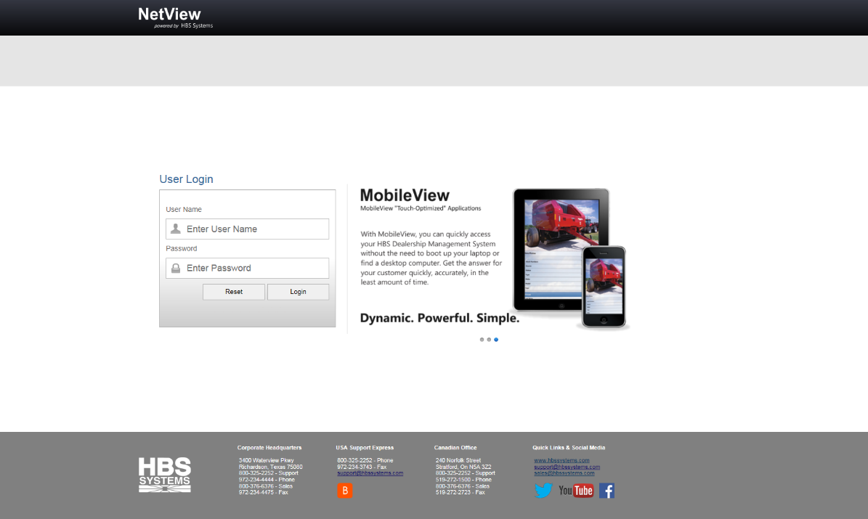

Logging In: To log in, type in your user name and password in the appropriate fields, then click Login.

- To clear the fields, click Reset.
- If you are having trouble logging in:
  - Make sure both your user name and password are correct.
  - Make sure you have typed your user name in the field labeled “User Name” and your password in the field labeled “Password.”
  - You can try 3 times to type your information in. After the third failed try, the system will not let you log in for 15-30 seconds. When that time has passed, you may try again.
  - If you have forgotten your user name and/or password, contact your system administrator.

Contacting HBS Systems: Contact information for HBS Systems and relevant web links are located at the bottom of the Login Page.



- Under the Corporate Headquarters heading, you will the find addresses and phone/fax numbers for the main office.
- Under the USA Support Express heading, you will find the phone/fax numbers and email address for USA Support. There is also a link to the Bomgar™ Support Portal.
- Under the Canadian Office heading, you will find the addresses and phone/fax numbers for the Canadian office.
- Under the Quick Links & Social Media heading, you can access the HBS main website, email Support and Sales, and access HBS’s social media pages.

